Once a user register an account in firebase, their name will be shown below

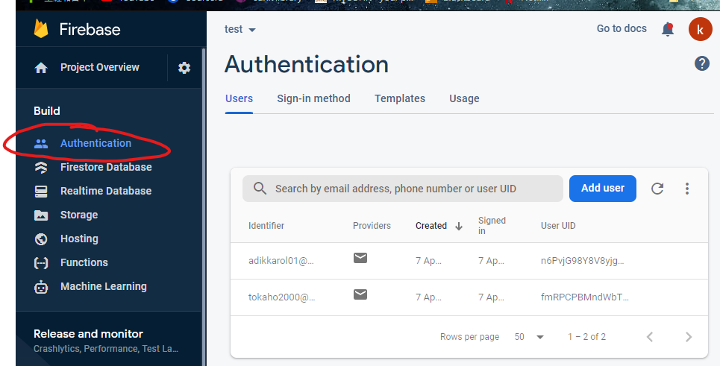

However, this doesn’t mean that he finished the signup

The user still need to verify their email address

At the same time, a user profile will be created under firestore database

